Assignment for Module 10
The assignment for Module 10 involves problems for schema conversion. Problems 1 to 4 involve the ERD in Figure 1.
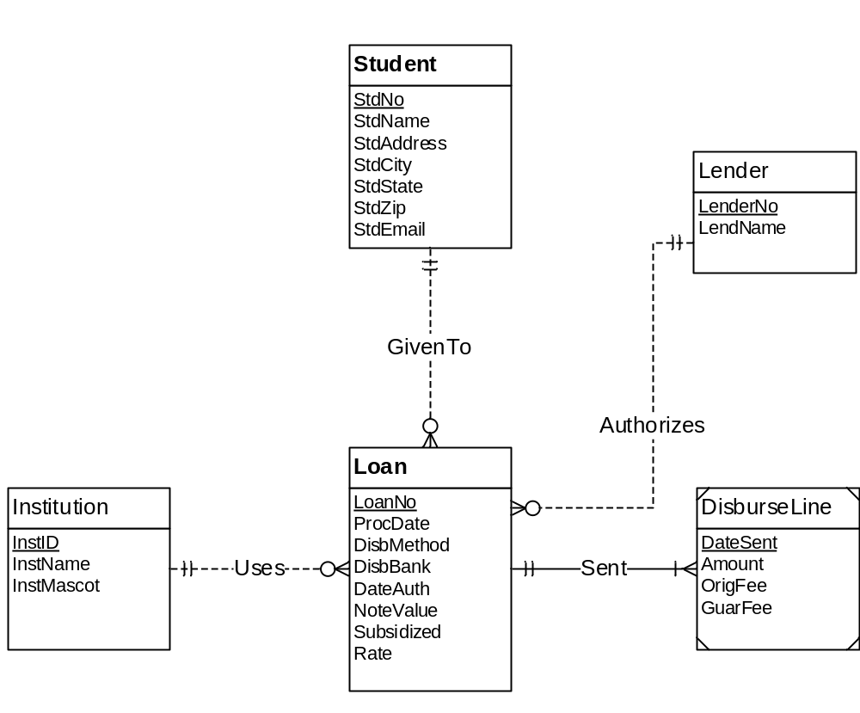
Figure 1: ERD for Problems 1 to 4
1. Requirements for Data Modeling Problems
- For the ERD in Figure 1, you should indicate the applications of the entity type rule. For each entity type rule application, you should identify the table name, primary key, and other columns. You do not need to write CREATE TABLE statements.
SOLUTION :
Student(StdNo, StdName, StdAddress, StdCity, StdState, StdZip, StdEmail)
Institution(InstID, InstName, InstMascot)
Loan(LoanNo, ProcDate, DisbMethod, DisbBank, DateAuth, NoteValue, Subsidized, Rate)
Lender(LanderNo, LendName)
DisburseLine(DateSent,Amount, OrigFee, GuarFee)
Total of 5 Entity Type Rule Appilications

- For the ERD in Figure 1, you should indicate applications of the 1-M relationship rule. For each 1-M relationship rule application, you should indicate the changes to the tables you listed in problem 1 including foreign key columns and NOT NULL constraints for foreign keys if necessary.
SOLUTION :
Student(StdNo, StdName, StdAddress, StdCity, StdState, StdZip, StdEmail)
Institution(InstID, InstName, InstMascot)
Lender(LanderNo, LendName)
Loan(LoanNo, InstID,StdNo, LenderNo, ProcDate, DisbMethod, DisbBank, DateAuth, NoteValue, Subsidized, Rate)
FOREIGN KEY(InstID) REFERENCES Institution
FOREIGN KEY(StdNo) REFERENCES Student
FOREIGN KEY(LenderNo) REFERENCES Lender
InstID NOT NULL
StdNo NOT NULL
LenderNo NOT NULL
DisburseLine(DateSent, LoanNo, Amount, OrigFee, GuarFee)
FOREIGN KEY(LoanNo) REFERENCES Loan
LoanNo NOT NULL
Total Four 1-M Relationship Rule Appilications

- For the ERD in Figure 1, you should indicate applications of the M-N relationship rule. For each M-N relationship rule application, you should list the table name, primary key, and other columns.
SOLUTION:
No M-N Relationship is present, so Zero M-N Relationship Rule Appilications

- For the ERD in Figure 1, you should indicate applications of the identifying relationship rule. For each identifying relationship rule application, you should indicate the changes to the tables you listed in problem 2.
SOLUTION :
Student(StdNo, StdName, StdAddress, StdCity, StdState, StdZip, StdEmail)
Institution(InstID, InstName, InstMascot)
Lender(LanderNo, LendName)
Loan(LoanNo, InstID,StdNo, LenderNo, ProcDate, DisbMethod, DisbBank, DateAuth, NoteValue, Subsidized, Rate)
FOREIGN KEY(InstID) REFERENCES Institution
FOREIGN KEY(StdNo) REFERENCES Student
FOREIGN KEY(LenderNo) REFERENCES Lender
InstID NOT NULL
StdNo NOT NULL
LenderNo NOT NULL
DisburseLine(DateSent, LoanNo, Amount, OrigFee, GuarFee)
FOREIGN KEY(LoanNo) REFERENCES Loan
Only 1 Identifying Relationship rule appilication is present.
Here LoanNo is made to Primary Key. Hence NOT NULL constraint can be removed.

- Convert the ERD shown in Figure 2 into tables. List the conversion rules used and table design. For each table, you should list the primary key, foreign keys, other columns, and NOT NULL constraints for foreign keys if necessary. You do not need to write CREATE TABLE statements.
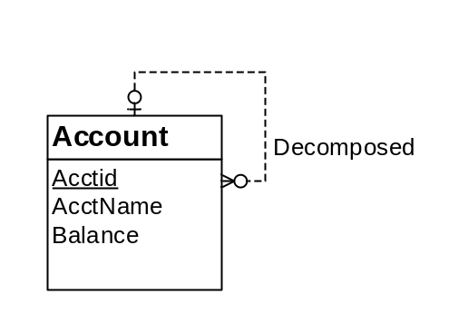
Figure 2: ERD for Conversion Problem 5
SOLUTION:
Account(Acctid, DecomposedAccount,AcctName, Balance)
FOREIGN KEY(DecomposedAccount) REFERENCES Account

Conversion rules
- Use the entity type rule to convert each entity type
- Use the 1-M relationship rule for the relationship

- Convert the ERD shown in Figure 3 into tables. List the conversion rules used and table design. For each table, you should list the primary key, foreign keys, other columns, and NOT NULL constraints for foreign keys if necessary. You do not need to write CREATE TABLE statements.
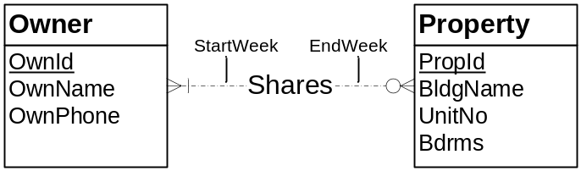
Figure 3: ERD for Conversion Problem 6
SOLUTION:
Owner(OwnId, OwnName, OwnPhone)
Property(PropId, BldgName, UnitNo, Bdrms)
Shares(OwnId, PropId, StartWeek, EndWeek)
FOREIGN KEY(OwnId) REFERENCES Account
FOREIGN KEY(PropId) REFERENCES Account

